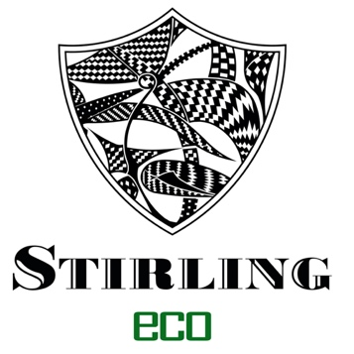

***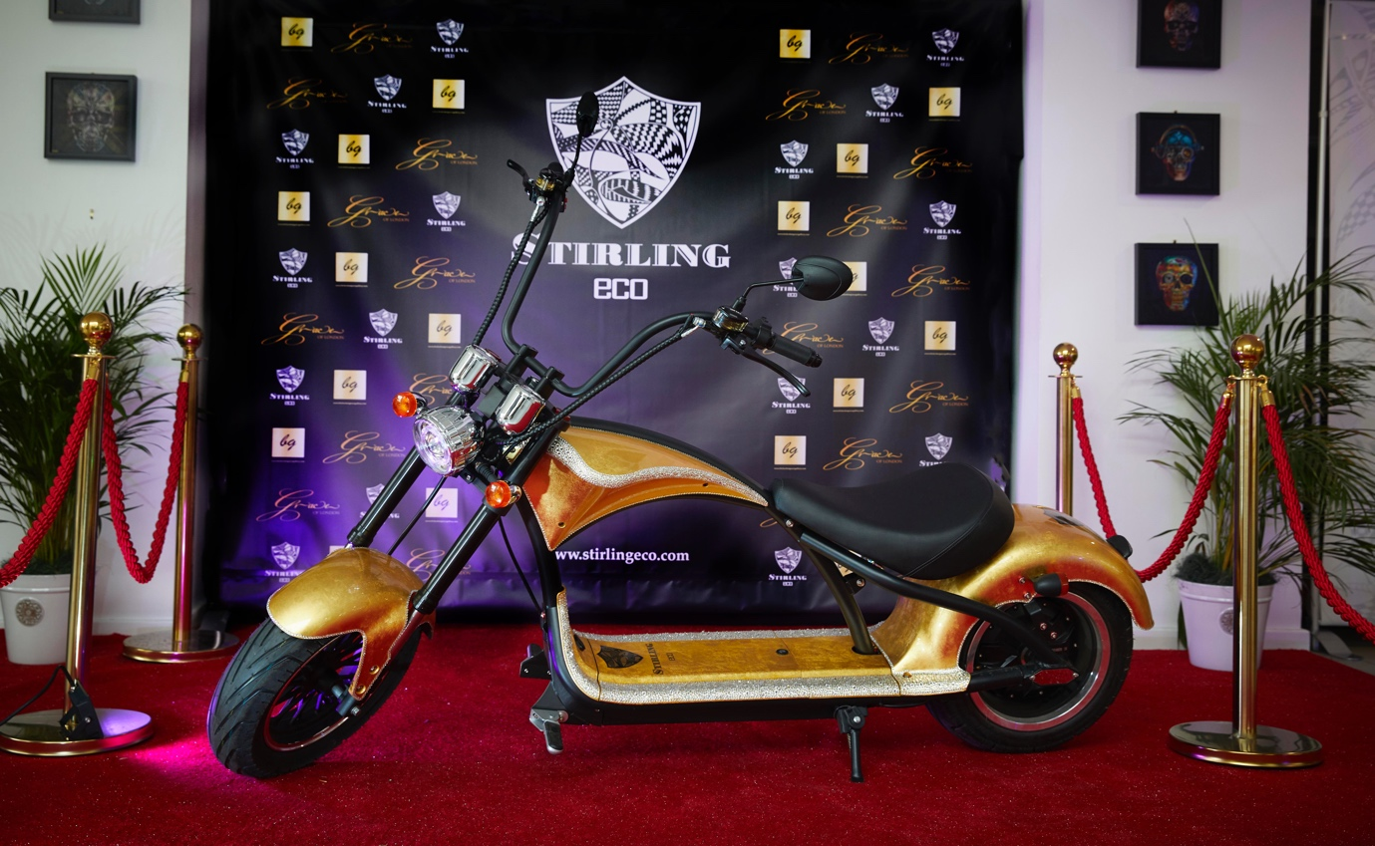*STIRLING ECO - MOTORCYCLE LIVE UPDATE**

**Busy programme in prospect for Electric Commuter Motorcycle manufacturers, Stirling Eco at Motorcycle Live:**

* **Top UK airbrush artist in bike customising action**
* **Be photographed on 24 Carat Gold bike**
* **Test ride a Stirling Eco bike at the show**
* **Celebrity appearances and photo opportunities**
* **Check out the Stirling Eco range**
* **Ultra-special Show offer…**

**3rd December 2021**: Stirling Eco, whose sustainable and affordable electric urban motorcycles will be making their debut at Motorcycle Live at the NEC this weekend, have a raft of different activities going on throughout the show from 4th to 12th December.

The London-based outfit’s multi-faceted stand, which reflects Stirling Eco’s unique approach to the world of two-wheels, can be found in Hall 2. It will feature five models from the current range, and the company will be running a special show promotion throughout, which means that visitors could be the proud owner of a Stirling Eco bike for under £2000.

“We wanted to celebrate our debut at Motorcycle Live with a bang,” explains Rob Grace, founder and CEO of Stirling Eco, “and we think that our Show Offer should prove really attractive to anyone who’s looking for sustainable, stylish two-wheel transport, with technical back up and manufacturer aftersales service - at a price that is about as affordable as you are ever going to get!”

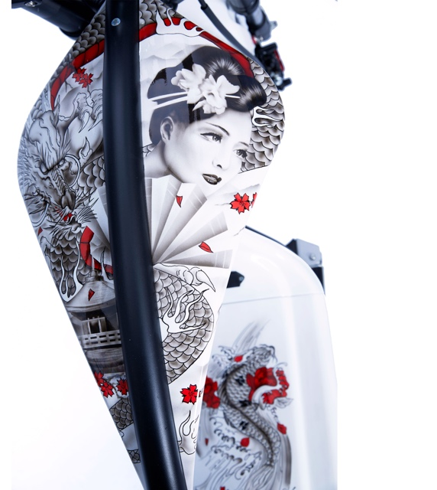

Visitors to the show will have the chance to have their photo taken on Stirling Eco’s 24 carat-gold liveried Electro Ride, which is situated on the VIP area of the stand, while those attending on both Saturdays or the middle Wednesday of Motorcycle Live can watch leading UK airbrush artist, Dave Bristow, demonstrating his craft, working to produce custom-painted Electro Rides.

Look out for famous faces popping up at Stirling Eco over the course of the show, as the bikes have already found their way onto the driveways of numerous celebrities, and, throughout Motorcycle Live, Comic-Book heroes Deadpool and The Punisher will be on the stand to meet, greet and be photographed.

Stirling Eco should be easily locatable through the five-meter tall flag flying from its stand in Hall 2, but the company’s bikes can also be found in other locations. The company is proud to have one of its Stirling Eco bikes included in the electric motorbike display and a carbon-fibre/titanium Electro Ride will be available for test rides, for visitors who want to experience the bike, first hand, at the show.

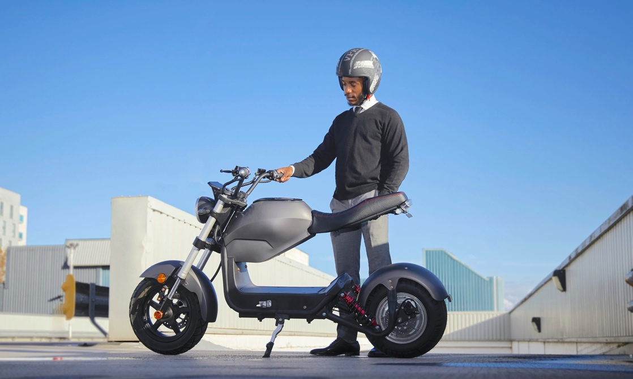

“We’re really looking forward to showing motorcycle enthusiasts what Stirling Eco is all about,” enthuses Creative Director, Tee Blackwood. ”Feedback from visitors is vital - and we will take it all onboard, so come along and talk to us and let us know what you think of what we are doing!”

**Stirling Eco can be found on stand 2B25 in Hall 2 at Motorcycle Live.**

***Ends***

For more media information about Stirling Eco bikes, as well as high-resolution photography, please contact:

**Gary Barak at Chicane**

[gary@chicane.marketing](mailto:gary@chicane.marketing)

Tel: 01923 265894

For more information regarding Stirling Eco please contact:

**Rob Grace or Tee Blackwood at Stirling Eco**

[info@stirlingeco.com](mailto:info@stirlingeco.com)

**Editor’s notes**

**Stirling Eco** [**https://stirlingeco.com**](https://stirlingeco.com)

Fast Forward to the Future of Urban Travel. Urban travel isn’t just about getting from A to B. Imagine zipping around the city without leaving a carbon footprint. Picture travelling tens of miles for pennies, not pounds and then imagine that while saving money and protecting the planet, your vehicle turns heads for all the right reasons. We’ve designed electric motorcycles, mopeds and microcars that are anything but ordinary. Stirling Eco combines innovative, planet-friendly technology with stylish designs to make urban travel fun, affordable and sustainable.

Stirling Eco has a varied range of electric commuter motorbikes, which range from the classic Trento Italian-style electric scooter through the urban commuter style Street Scene to the American-style Electro Ride, which is like a classic V-twin cruiser…. But without the V-twin! The bikes are great value and one of their key features is that they can be completely customised in look and feel, to whatever level someone wants.

**Motorcycle Live:** [**www.motorcyclelive.co.uk**](http://www.motorcyclelive.co.uk)